**Cursors**

**Calculate Interest for Fixed Deposit Amount Using Cursors.**

**set intrest as 0 and then update it using the program.**

**set 10% intrest for amount less than or equal to 1000.**

**20% for more then 1000 to 5000.**

**30% for above 5000.**

declare

cursor c is select * from BANK;

begin

for i in c

loop

if i.Amount<=1000 then

update BANK set interest=i.Amount*0.1 where ACCNo=i.ACCno;

elsif i.Amount>1000 and i.Amount<=5000 then

update BANK set interest=i.Amount*0.2 where ACCNo=i.ACCno;

else

update BANK set interest=i.Amount*0.3 where ACCNo=i.ACCno;

end if;

end loop;

end;

/

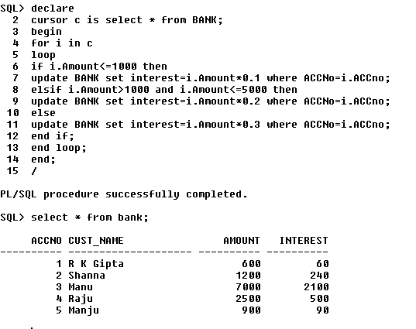

**2. Calculate Electricity Bill Using Cursors**

declare

cursor c is select * from bills;

begin

for i in c

loop

if i.unit<=100 then

update bills set charge=i.unit*0.1 where bno=i.bno;

elsif i.unit>100 and i.unit<=200 then

update bills set charge=i.unit*0.2 where bno=i.bno;

else

update bills set charge=i.unit*0.3 where bno=i.bno;

end if;

end loop;

end;

/

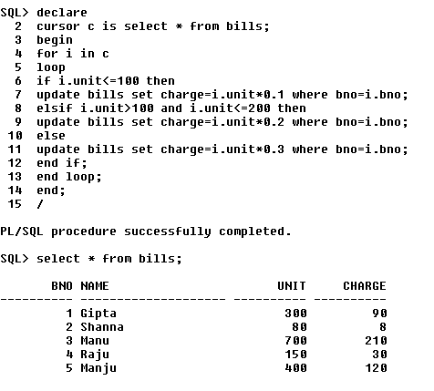

**3.Write PL/SQL code to UPDATE values in created tables by using Implicit Cursors.**

set serveroutput on;

declare

rowno number(20);

begin

update comp set salary=salary+1000;

if sql%notfound then

dbms_output.put_line('No amount updated');

elsif sql%found then

dbms_output.put_line('employee salary updated');

rowno:=sql%rowcount;

end if;

end;

/

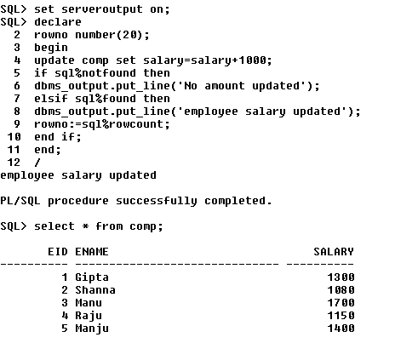

**4.Given the table works(emp_id,company_name,salary).write a cursor to**

**select the three highest paid employees from the table.**

set serveroutput on;

declare

cursor c is select * from (select * from work order by salary desc) where rownum <= 3;

r c%rowtype;

begin

open c;

loop

fetch c into r;

exit when c %notfound;

dbms_output.put_line(r.empid||' '||r.companyname||' '||r.salary);

end loop;

end;

/

